**PRACTICAL-8**

**AIM**

Gather information of any domain/website/IP address using following Information Gathering Tools.

* Nslookup
* Whois
* Tracert

**THEORY**

**NSLOOKUP:**

* nslookup is the name of a program that lets an Internet server administrator or any computer user enter a host name (for example, "whatis.com") and find out the corresponding IP address or domain name system (DNS) record.

**WHOIS:**

* **WHOIS** is a TCP-based query and response protocol that is commonly used to provide information services to Internet users.
* It returns information about the registered Domain Names, an IP address block, Name Servers and a much wider range of information services.

**TRACERT:**

* The traceroute command is used to determine the path between two connections. Often a connection to another device will have to go through multiple routers.
* The traceroute command will return the names or IP addresses of all the routers between two devices.

**IMPLEMENTATION**

**Nslookup:**

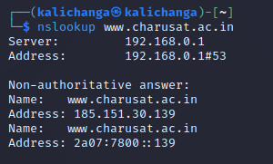

**Whois:**

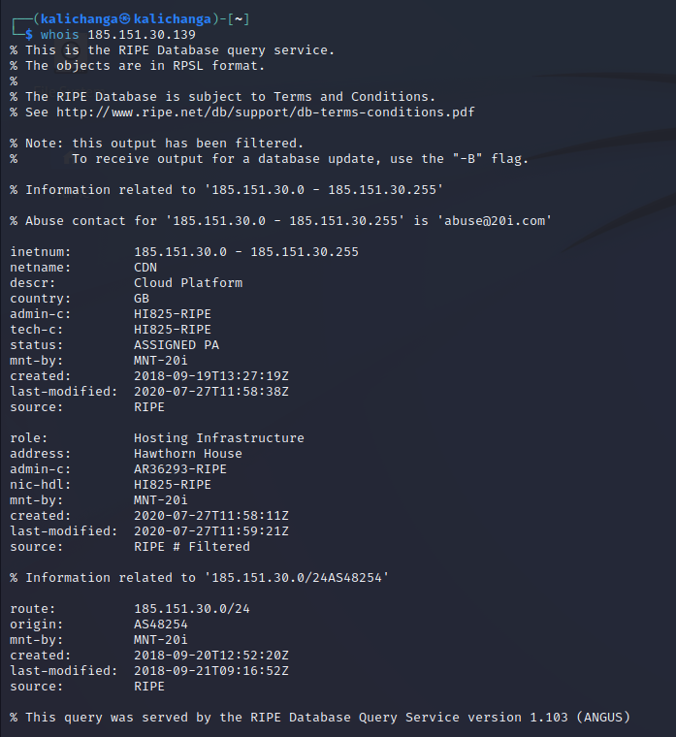

**Tracert:**

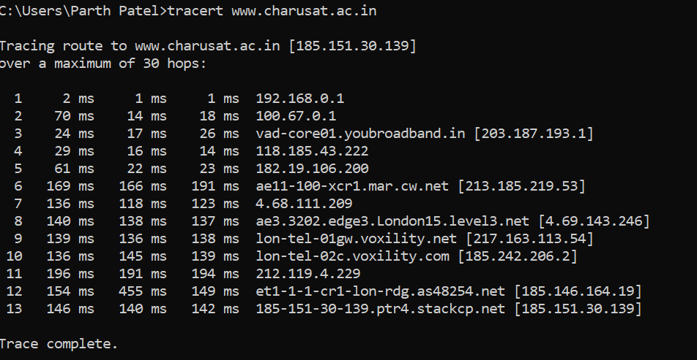

**CONCLUSION**

In this practical, we used different tools and frameworks to gather information of websites.